LETS UPGARDE

ASSINGMENT SOLUTION DAY 2

Name ***🡪Mohammad Ali Siddiqui***

***Course name🡪 Advance Courses in ethical hacking and cyber security.***

***ID🡪LUCYBS0820A299***

***DATE OF SUBMISSON 🡪 12/7/2020***

***Question 1:*** Create two different network

172.16.0.0/16

192.168.100.0/24

Create a route by adding a router and assigning a default gateway, so that they can

communicate.

**SOLUTION :-**

*According to question given t us we have to make 2 networks so we require*

1. *7 Generic pcs 🡪 form PC 0 to PC 6*
2. *2 switches of model 2950-24*
3. *A router*

*ARRANGE THE SYSTEM AS GIVEN below in the picture*

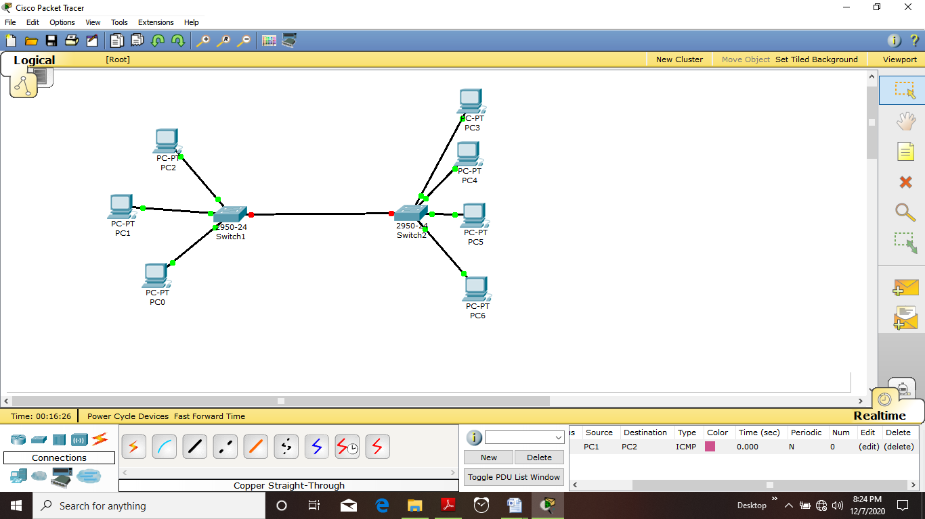

*On left hand side we have PC0 PC1 PC2 having IP as 192.168.100.1, 192.168.100.2 and 192.168.100.3 they are connected to a switch and having ether net 0/1, 0/2 , 0/3*

*On right hand side we have PC4 PC5 PC6 PC3 they are having an IP address of 172.16.0.0 type …it is of type b*

*Naturally PC 1 can contact with PC0 and PC 2because ther are under same subnet or same network so if we ping or send a packet virtually in it will travel*

*Same will be for PC3 , it can contact with PC 4 PC5 PC 6as it is in subnet of 225.255.0.0*

*It is shown as*

*Sending a packet for PC3 to PC5*

*It will be success*

*SEE IN “***EVENT LIST***”*

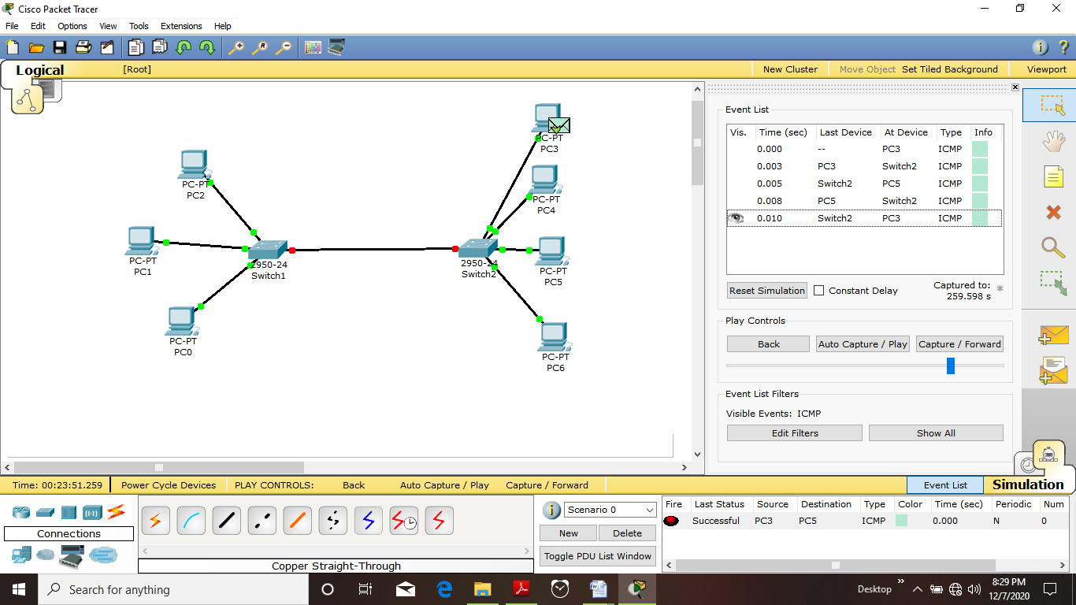

*Now try out to send packet form PC1 to PC 2*

*It will be a successful operation*

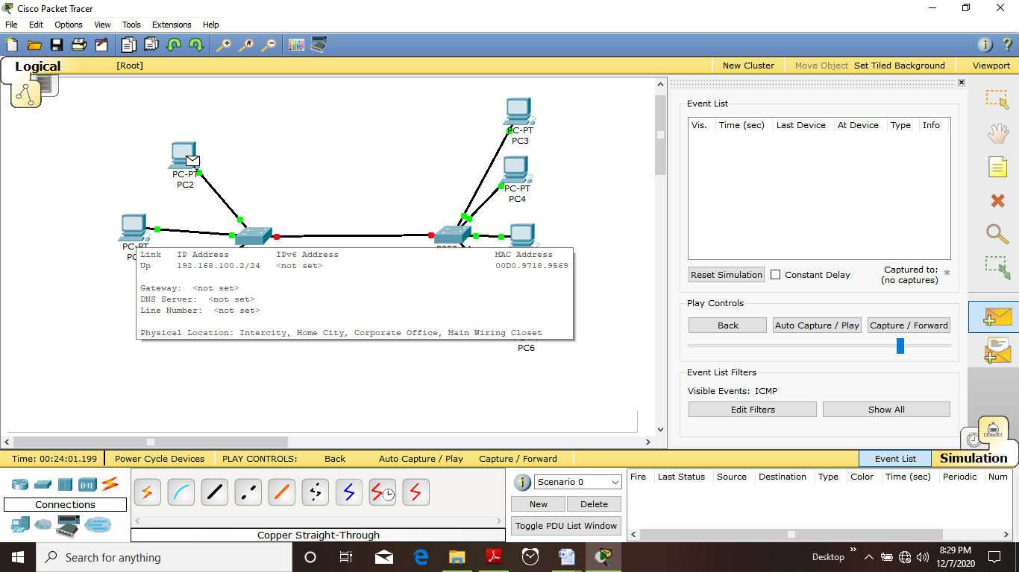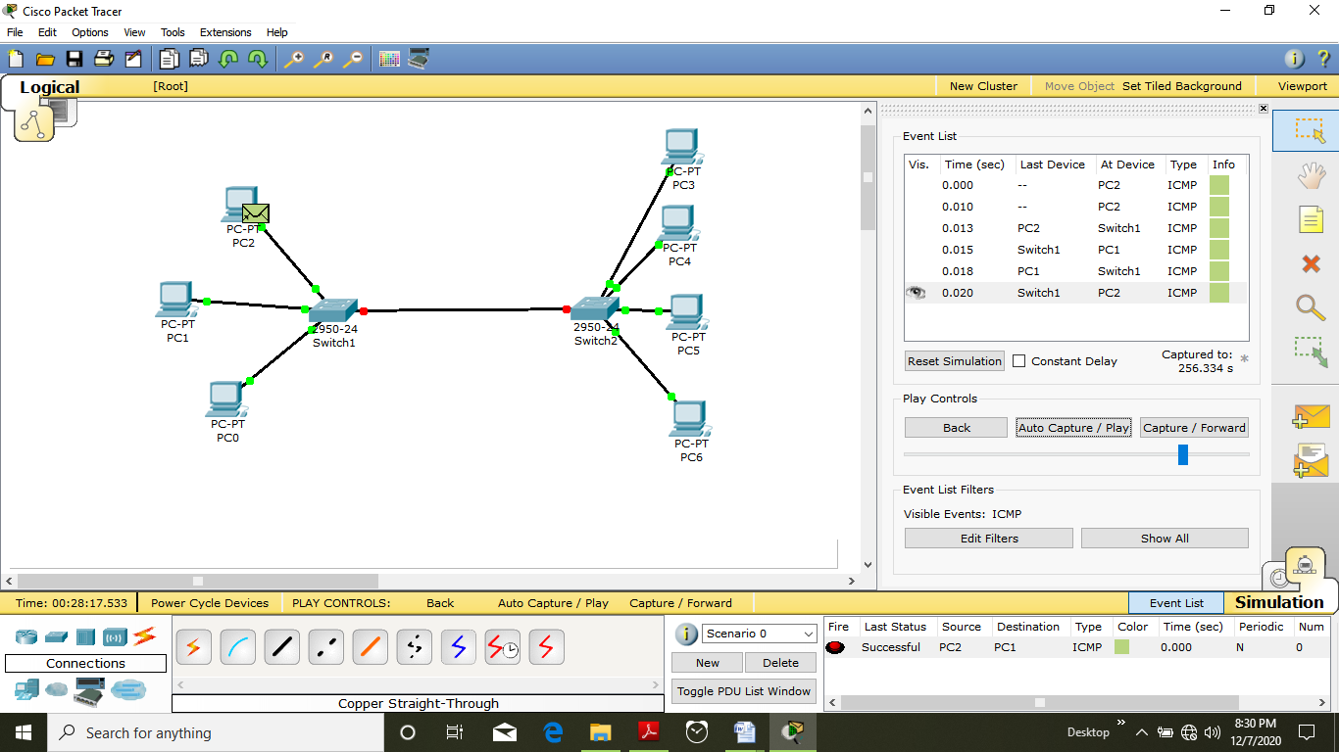

*Now try to send the packet form PC3 to PC 0*

*Naturally it will not communicate since subnet is different*

*See it is showing under event list failed*

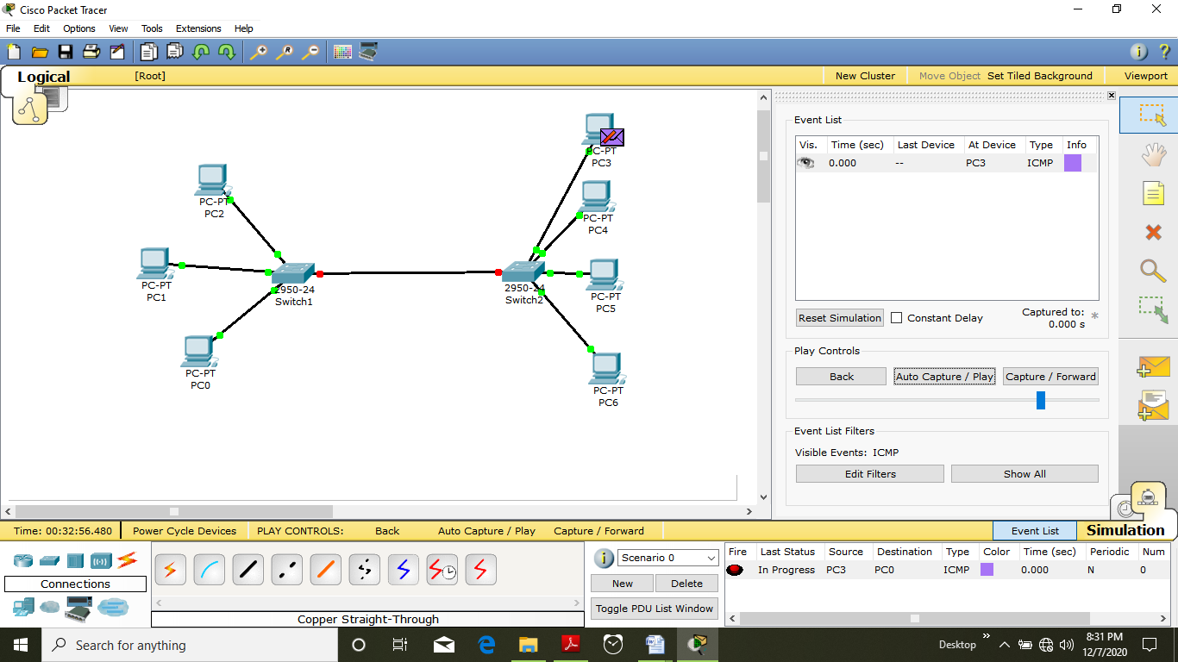

*Switch status*

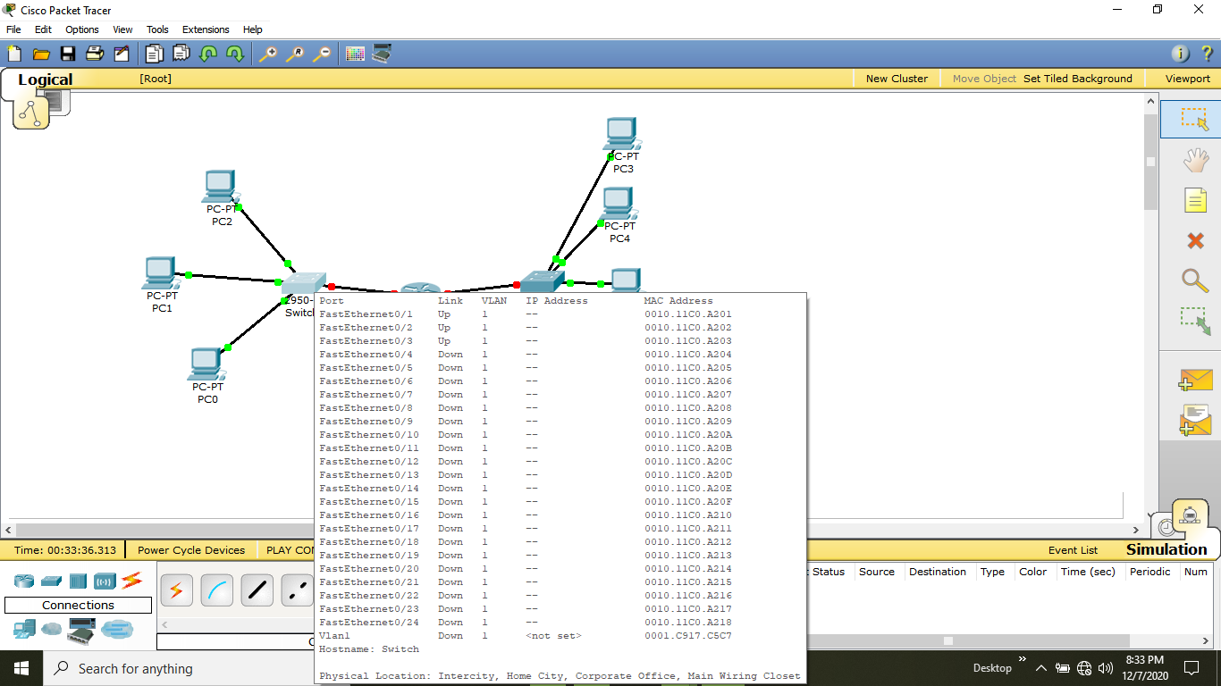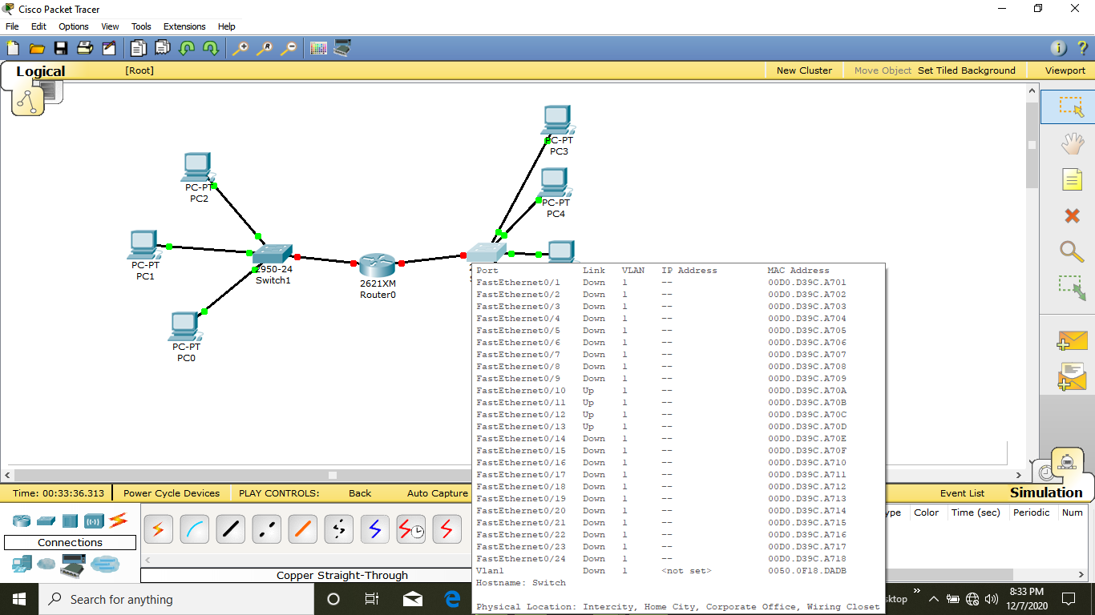

*Now connect in between the switch 0 and Switch 1 router named as router 0*

*It will have to connections named as Ethernet 0/0 and Ethernet 0/1*

*Now setup is like*

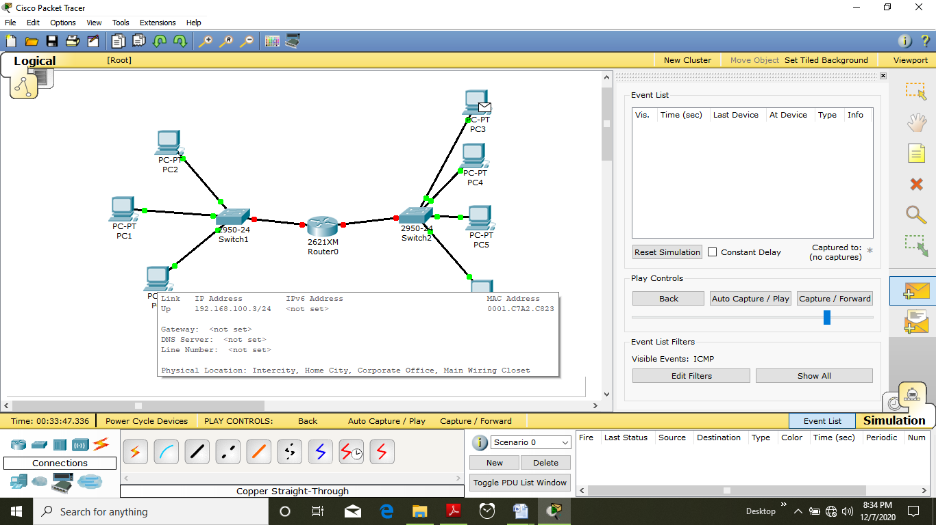

*Now simply click on router ------- >> Under config ------ >> Ether net 0/0 Provide it a IP address say 192.168.254.0 and power on ------------ >> Go to Ethernet 0/1 provide an IP address of 172.16.255.254*

*Subnet mask will automatically come in*

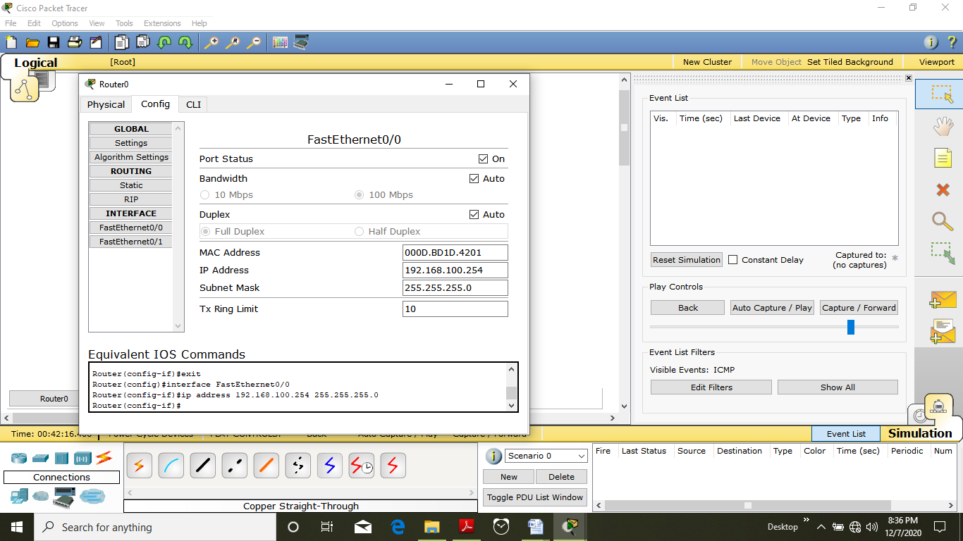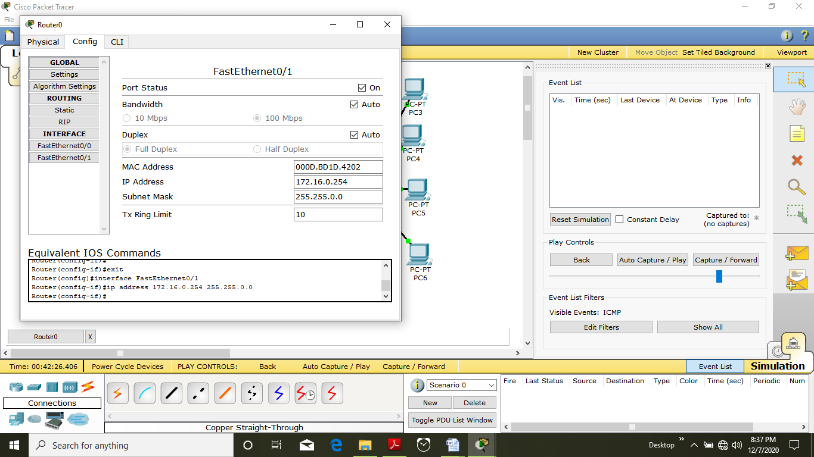

*After configuring Router Now try out to send package form PC3 to PC1*

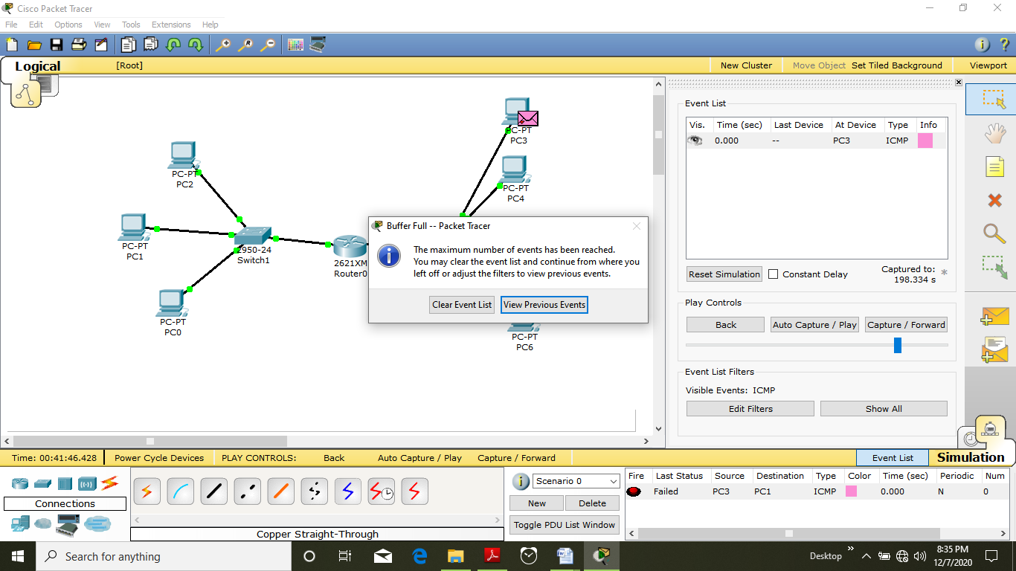

*Now give a gateway of PC0 PC1 PC 2 to IP of Ethernet 0/0 i.e as 192.168.100.254*

*Also give a gateway of PC3 PC4 PC5 PC4 to IP of Ethernet 0/1 I.e 172.16.255.254*

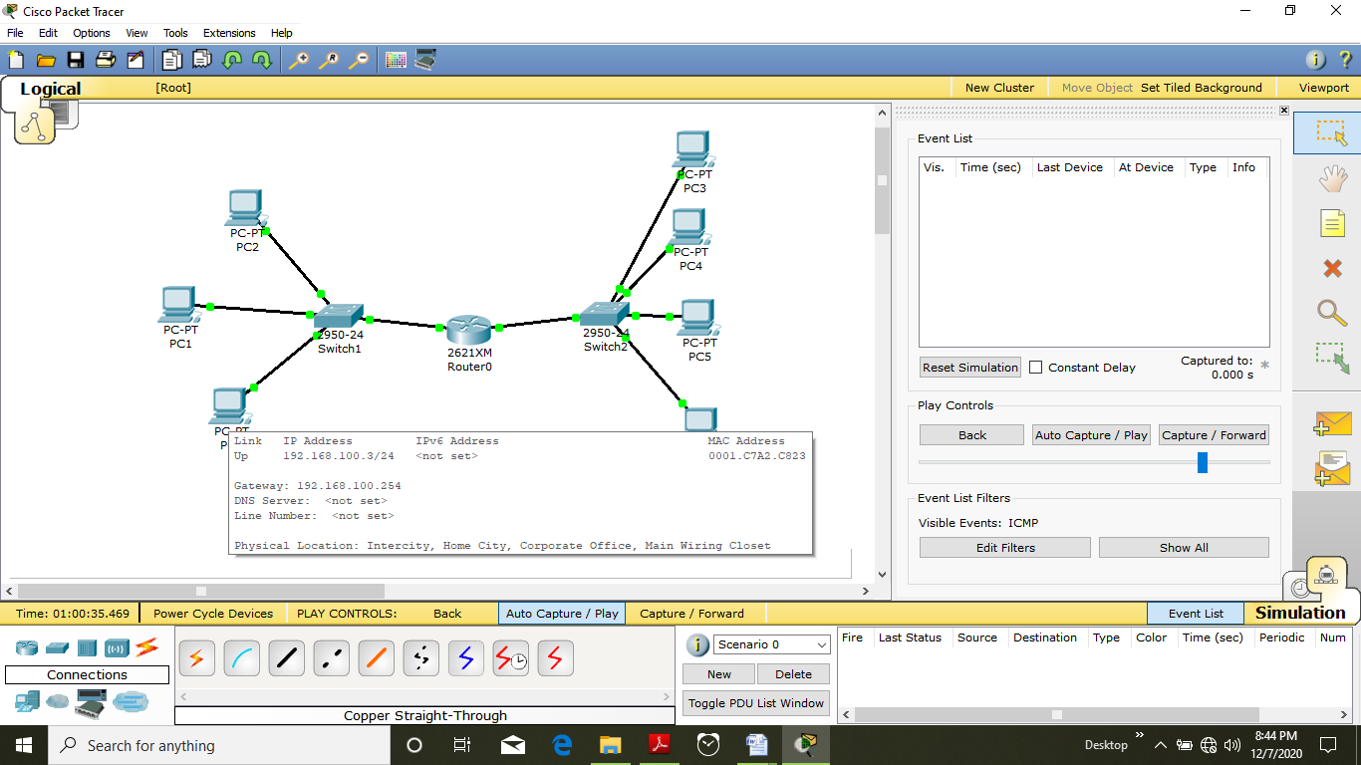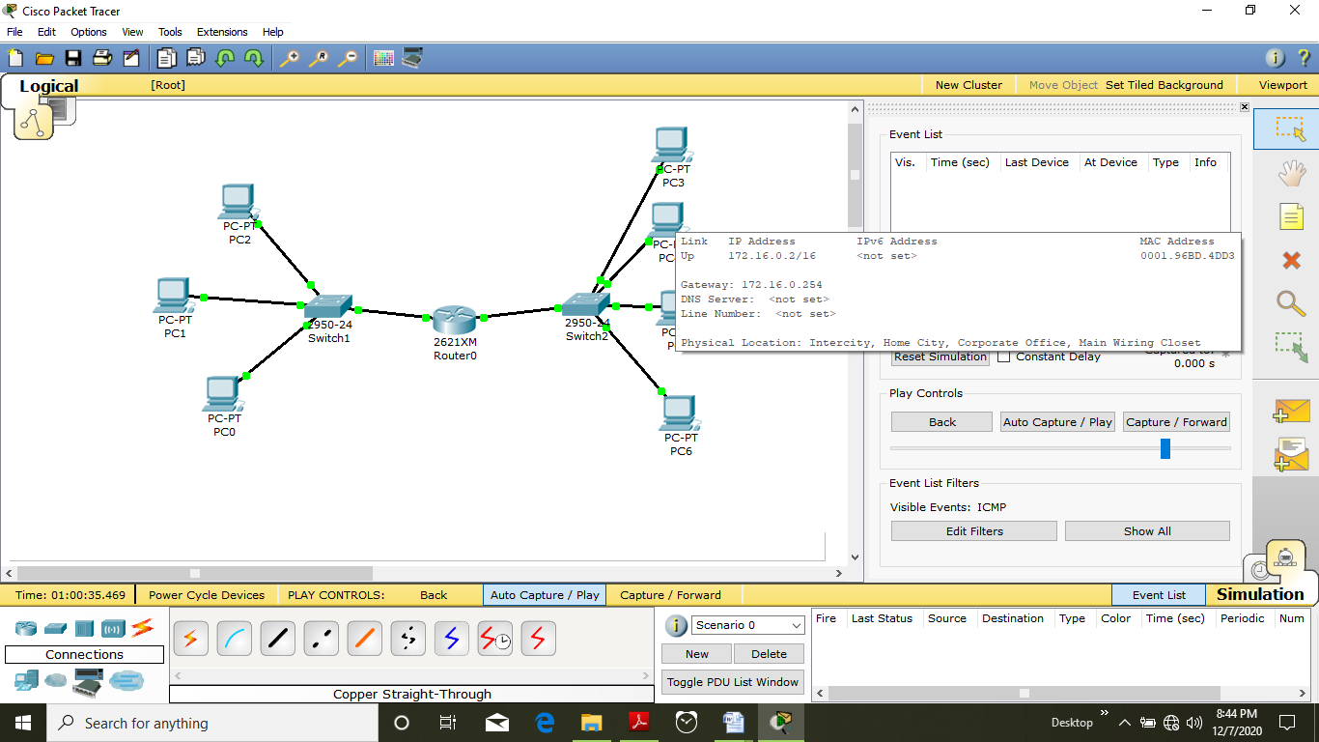

*Now try to send the package again From PC3 to PC 0*

*It will be successful because flow is like*

*Package in sending---------------------*

*PC3 🡪SWITCH 2 🡪ETHERNET 0/1🡪ROUTER🡪ETHERNET 0/0 🡪 SWITCH 1🡪PC0*

*Receiving flow -------------------*

*PC0 🡪SWITCH 1 🡪ETHERNET 0/0🡪ROUTER🡪ETHERNET 0/1 🡪 SWITCH 2🡪PC3*

*So it can shown on simulation as*

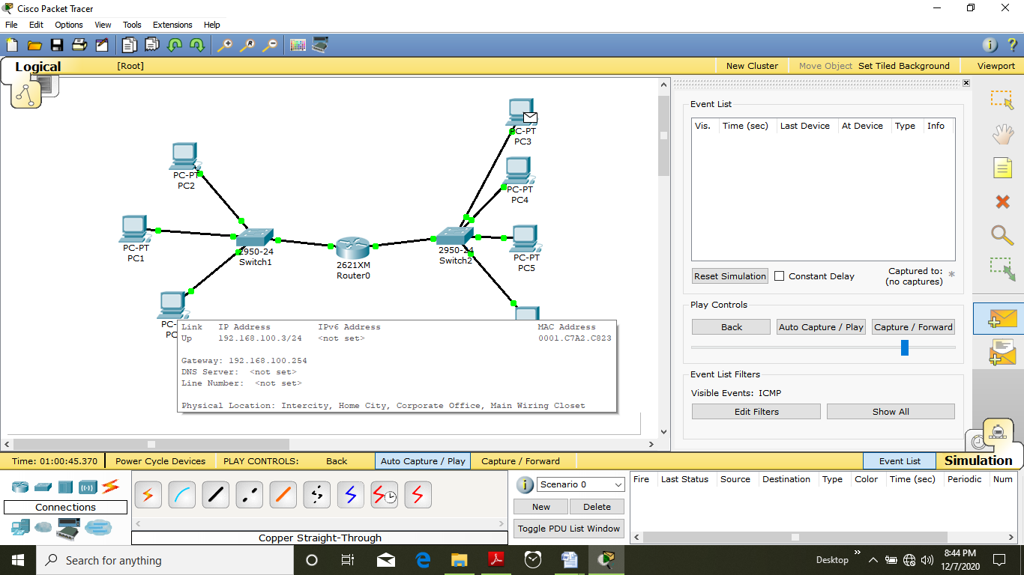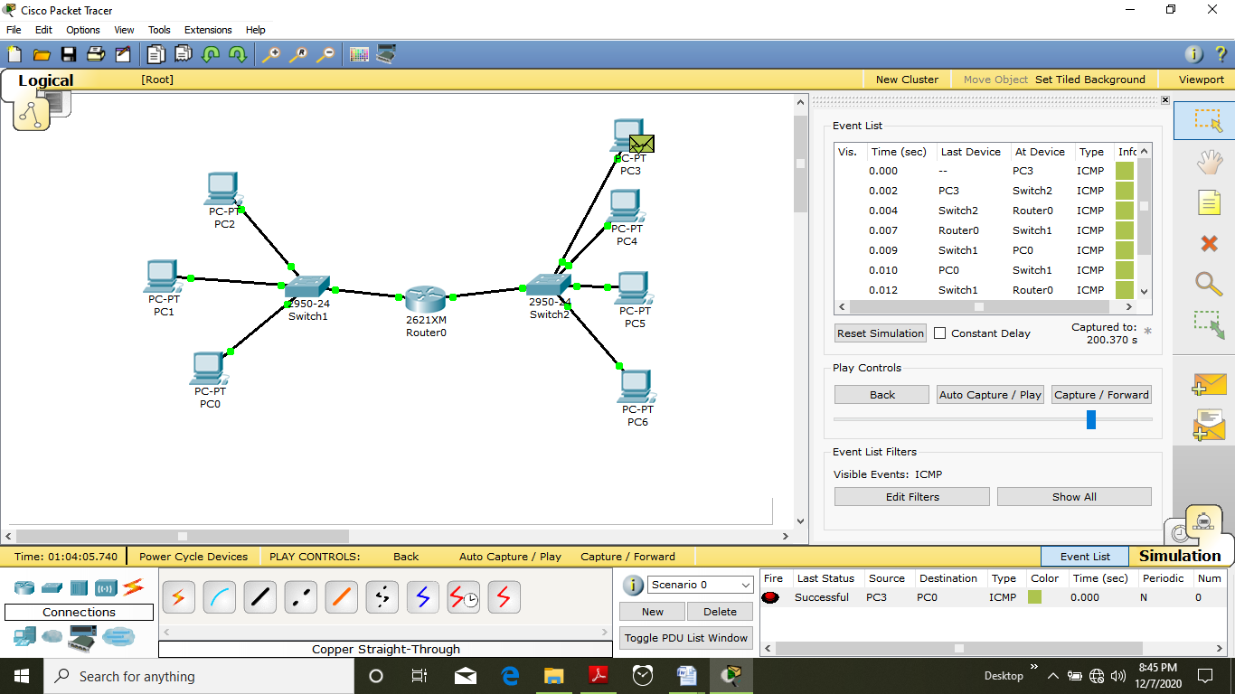

*Try to ping it on REAL TIME OPTION ON CISCO PACKET TRACER*

*ping form PC 5 to PC 3*

***command used is***

***ping 172.16.0.3***

*output will be*

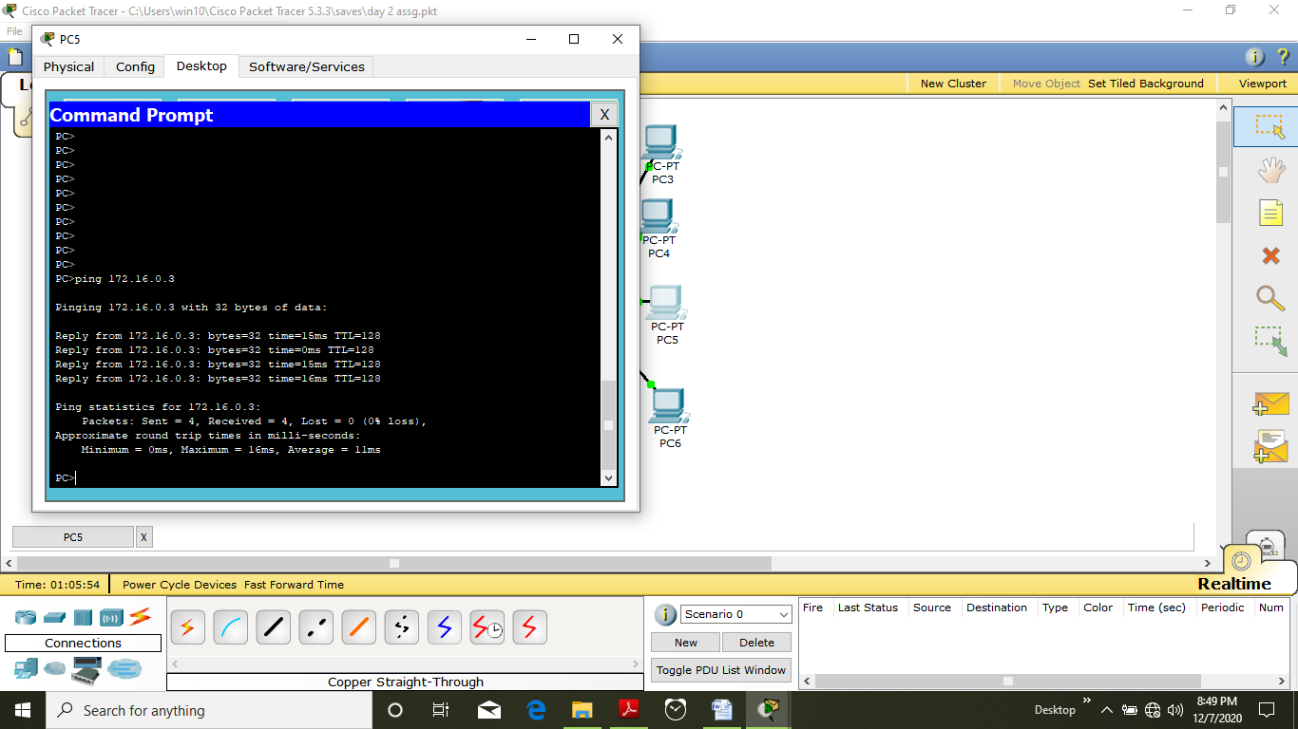

*Now try to ping from PC 5 to PC 2 in other network*

*Command used :* ***ping******192.168.100.3***

*Result is as follows*

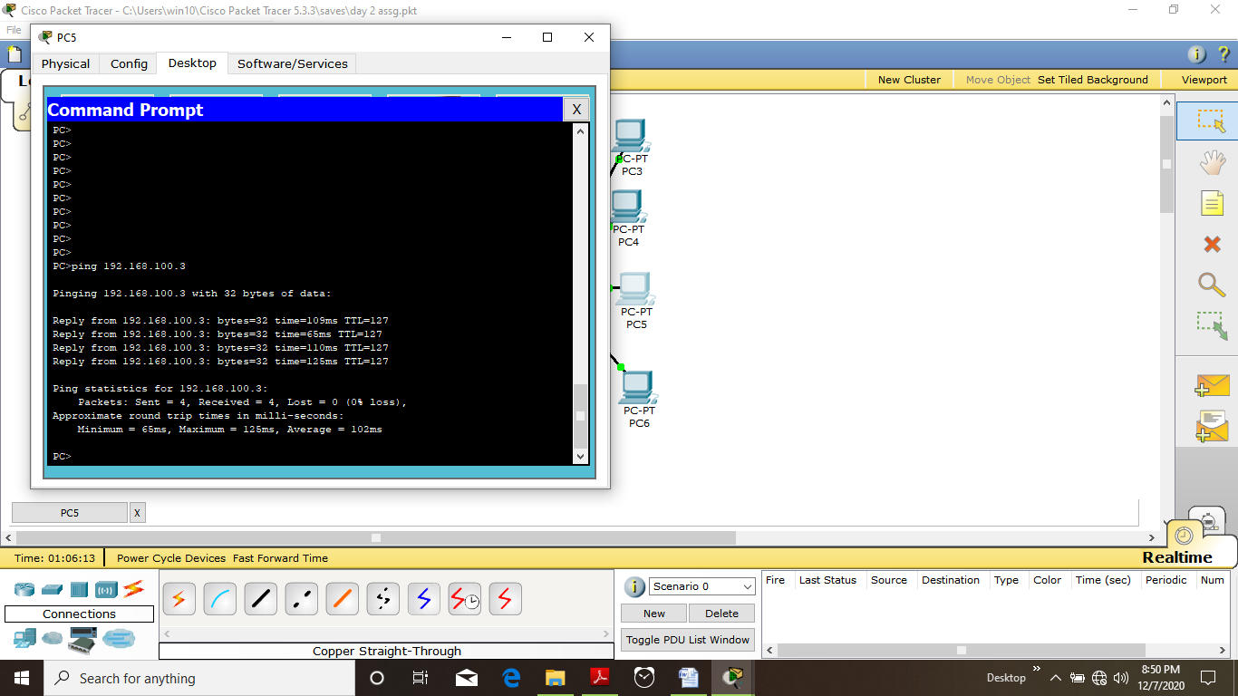

*So experiment was successfully done*

***Question 2:***

Create 6 systems in the same subnet and isolate their communication via VLAN.

***SOLUTION :-***

*According to question given to us we have to make a single networks and bifurcate it into networks using concept of VLAN so we require*

1. *6 Generic pcs 🡪 form PC 0 to PC 5*
2. *1 switches of model 2950-24*

*And it shall be arranged as follows:*

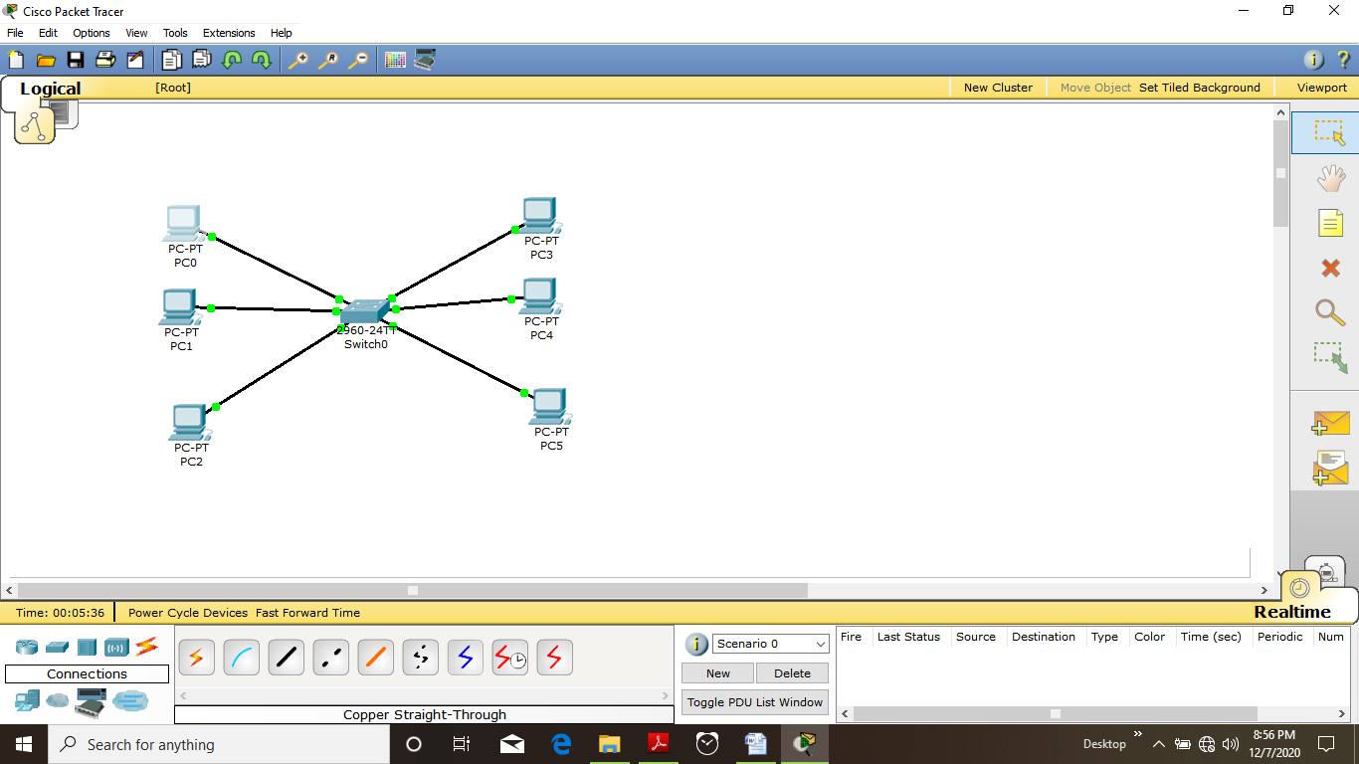

*Now provide the IP ADDRESSES to these pc from (PC0)192.168.100.1 to (PC5) 192.168.100.6*

*As follows*

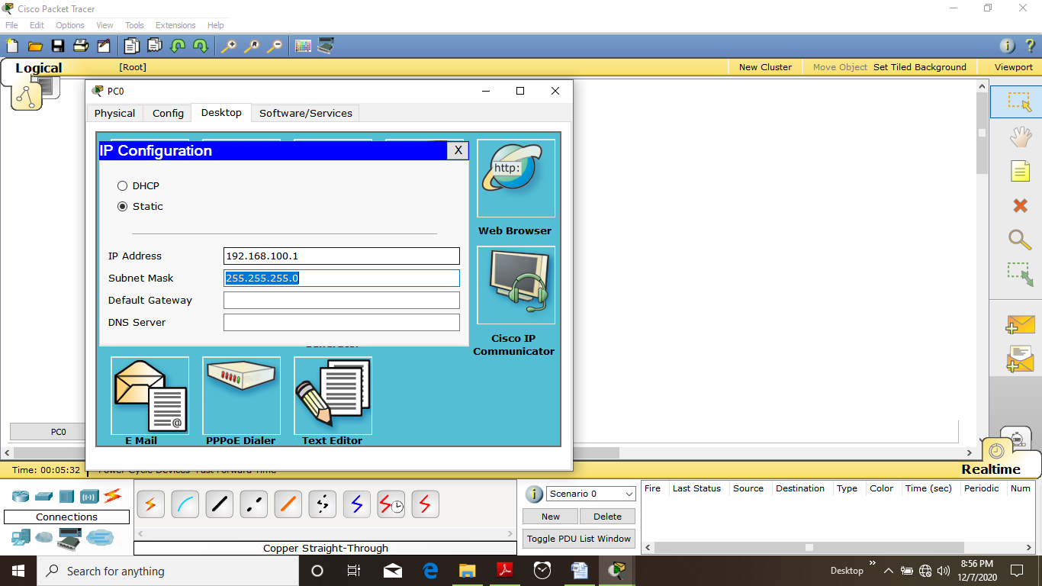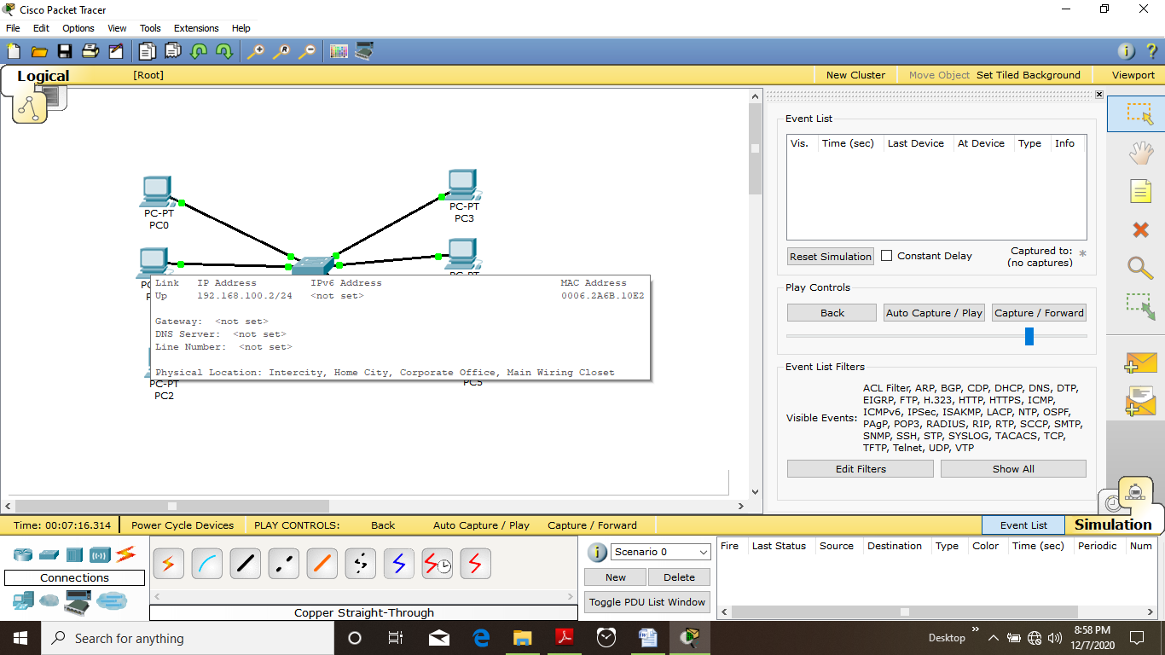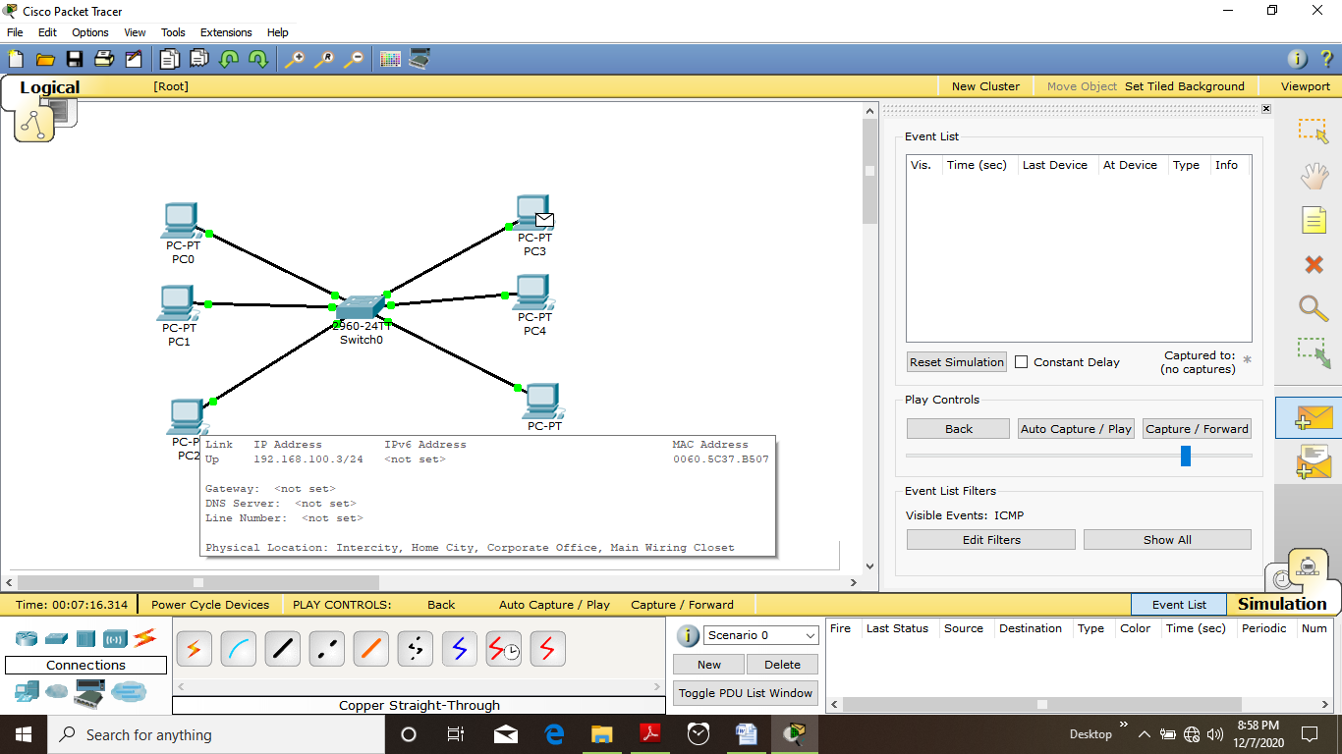

*Now try out in simulation to connect PC3 TO PC2*

*It will be a successful operation because all the system are in the same subnet mask of 2555.255.255.0*

*And under same network of 192.168.100.0*

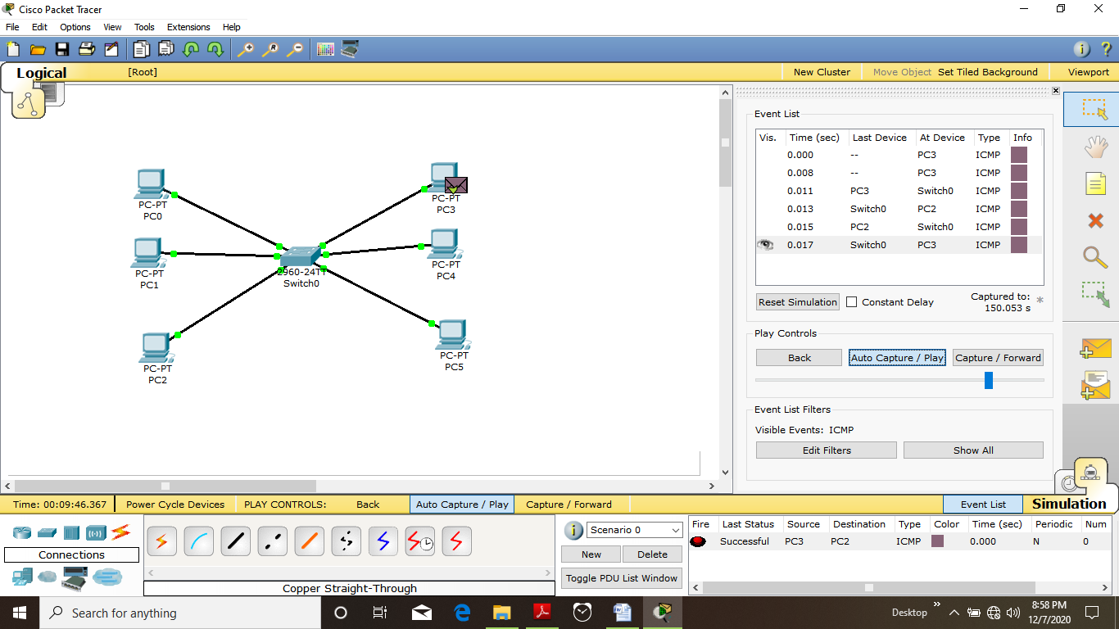

*In REALTIME FORM CMD WE CAN observe the same result :*

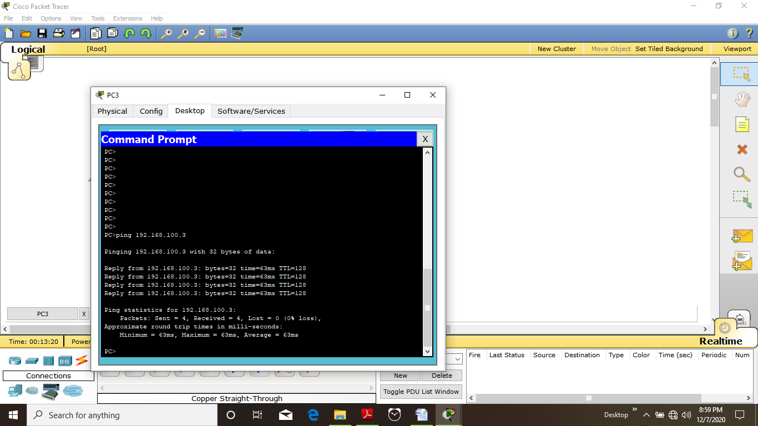

*Now how to break this network without using any component but by using VLAN*

* *Click on switch 0*
* *Goto config*
* *Add following 2 VLANs*

*🡪VLAN NUMBER =10*

*VLAN NAME = CITY*

*🡪 VLAN NUMBER =11*

*VLAN NAME = VILLAGE*

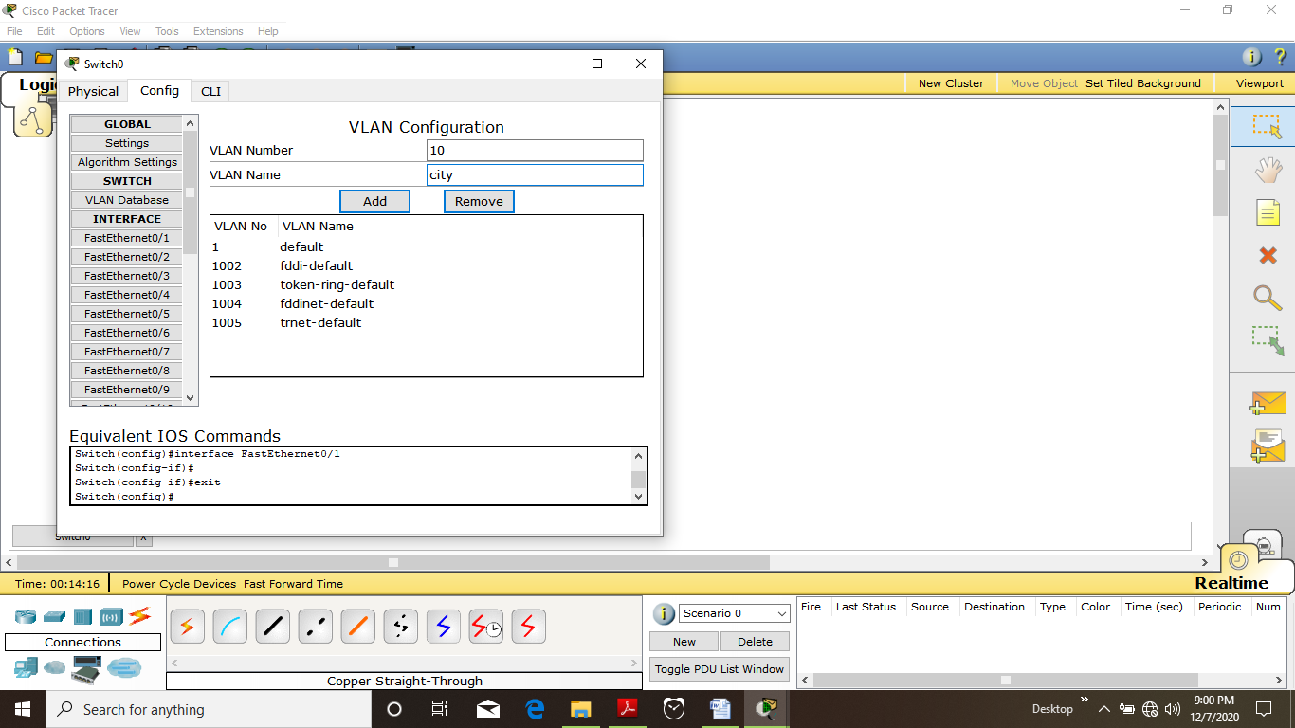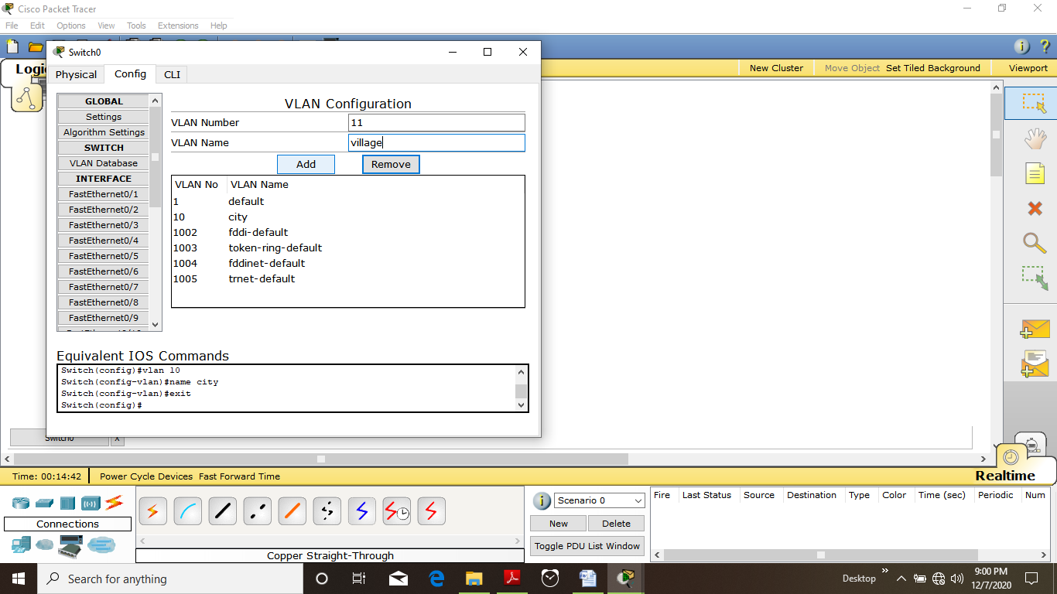

*Now configure the fast ETHERNET 0/1, ETHERNET 0/2, ETHERNET 0/3*

*FOR THEM VLAN NUMBER =10*

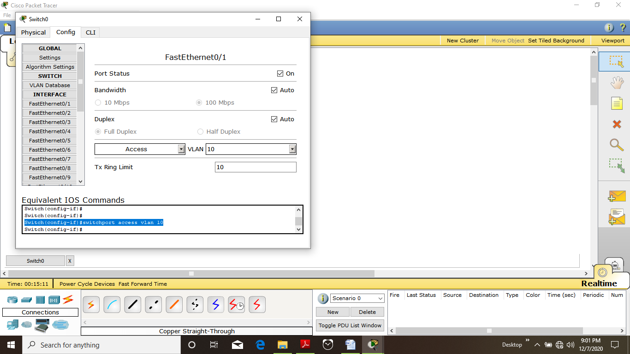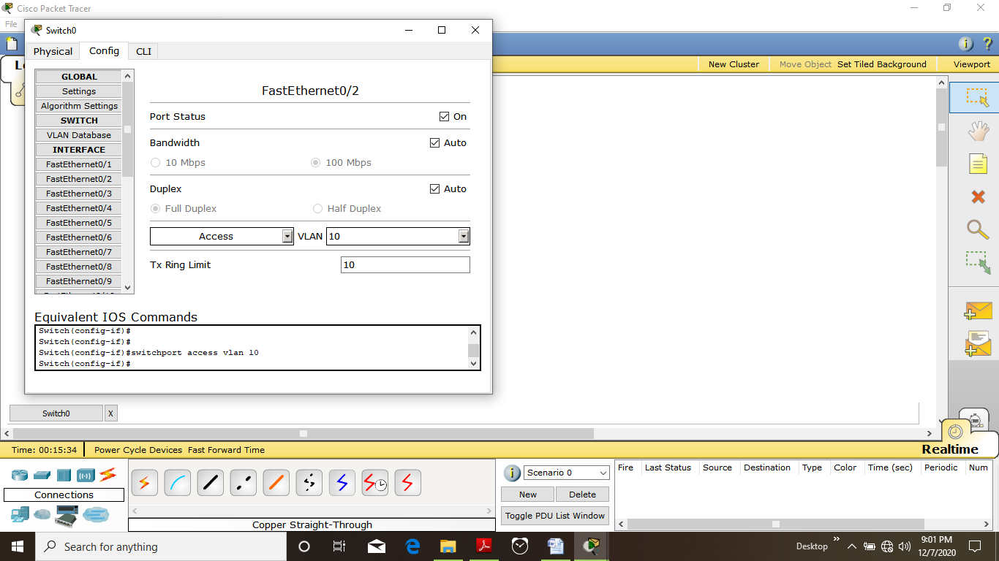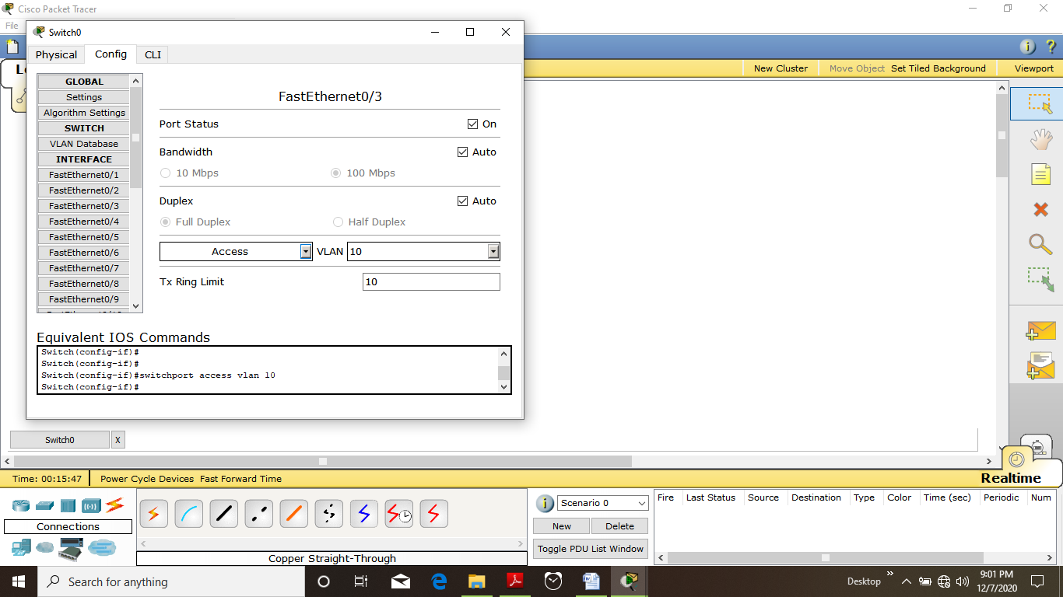

* *Now configure ETHERNET 0/4, ETHERNET 0/5 , ETHERNET 0/6 on VLAN NUMBER =11*

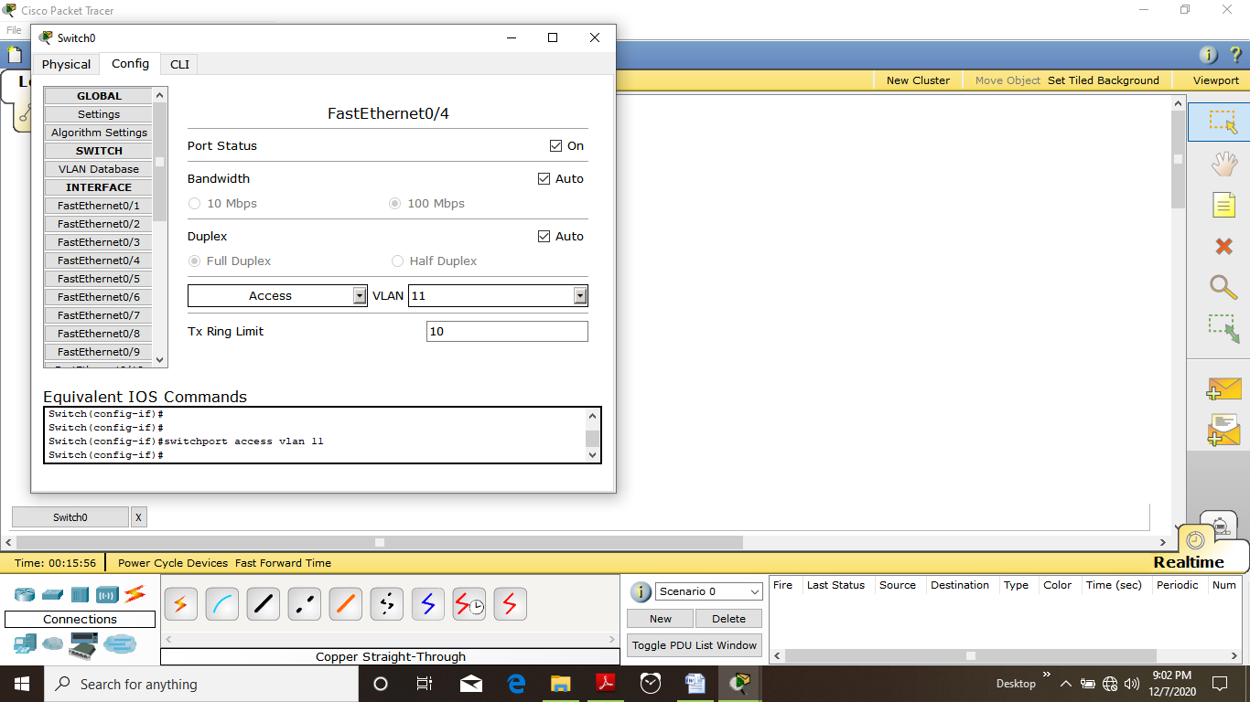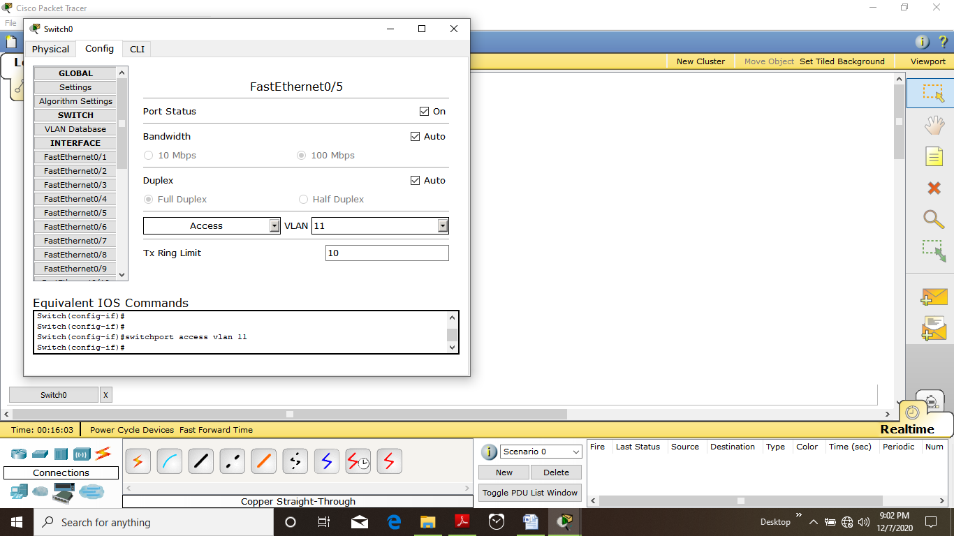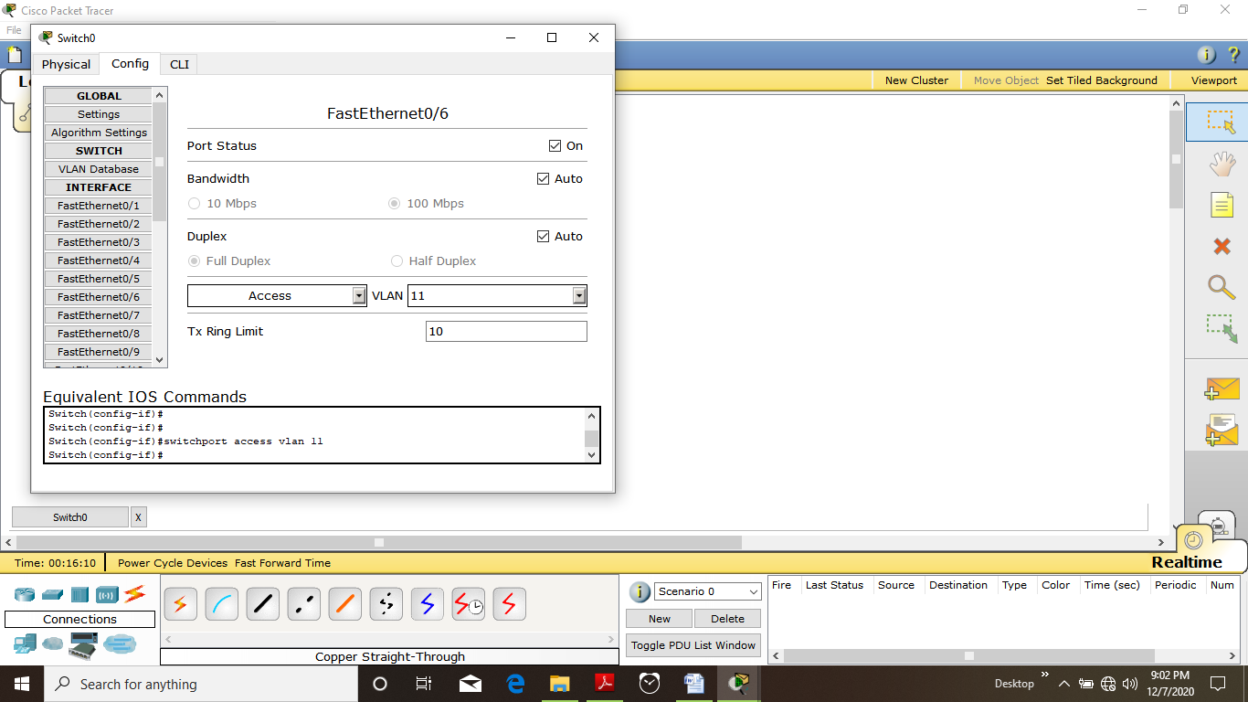

* *NOW SEE switch status by just placing cursor over it*

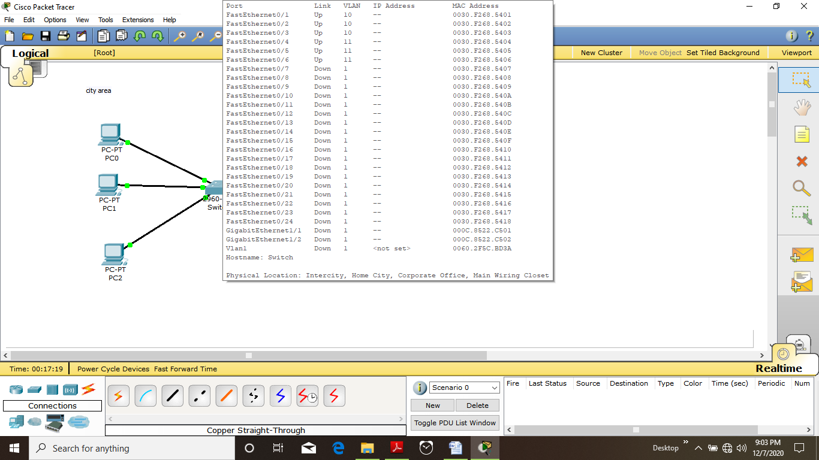

* *Try to make pc3 to connect with PC5 It will successful task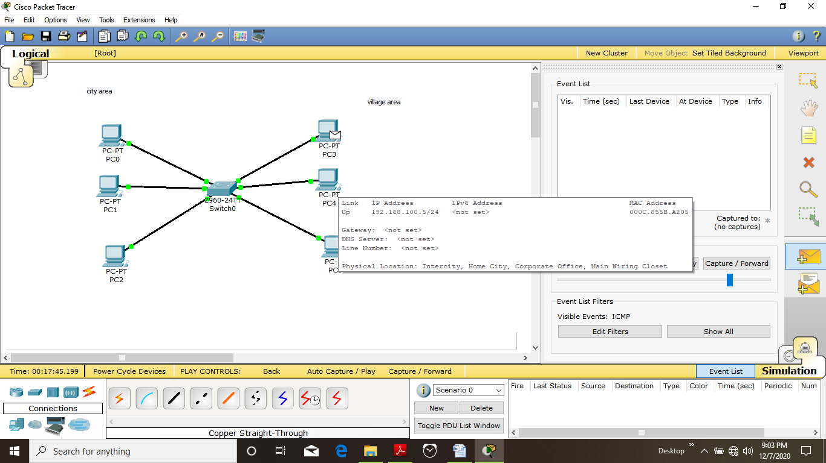*

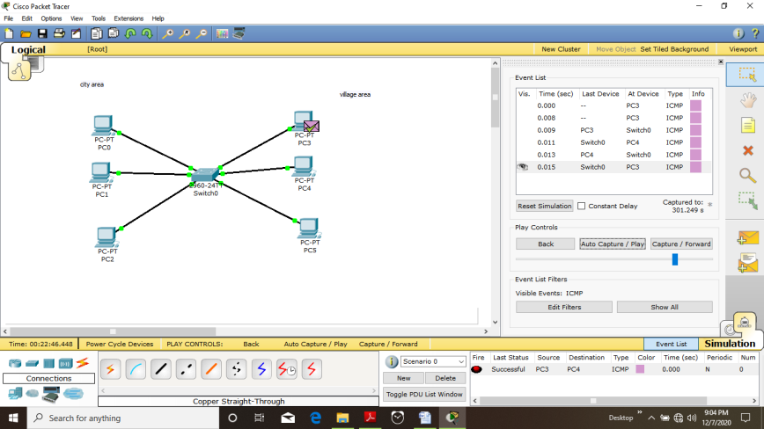

* *Try to connect PC 4 TO pc 1via simulation it will show process failed*

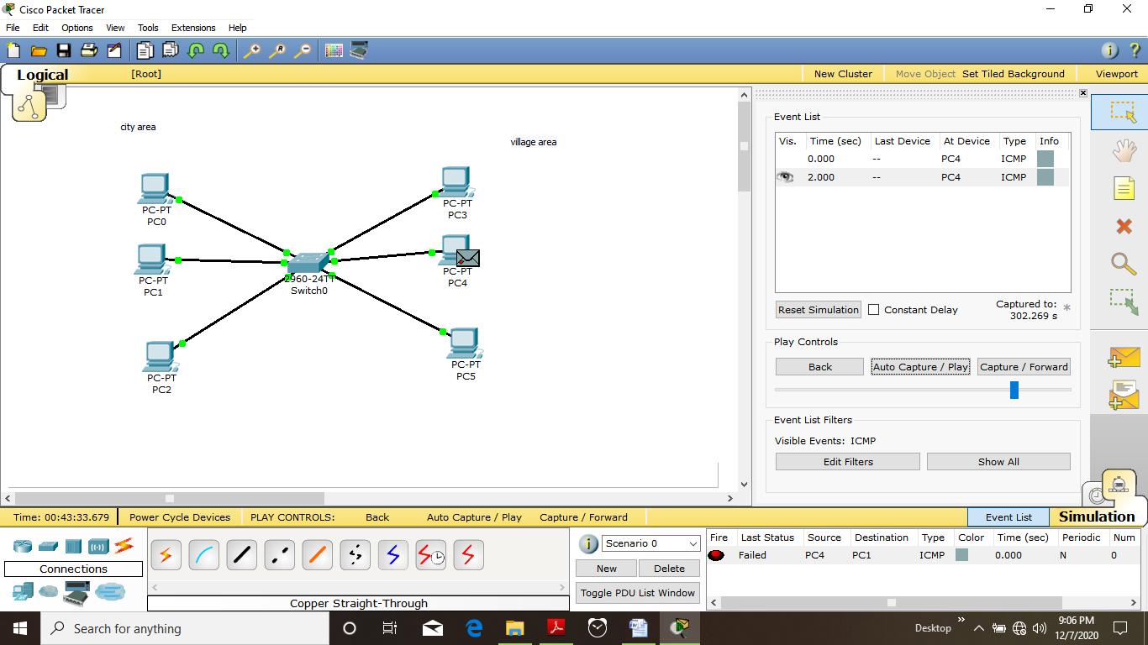

*With CMD it will show “REQUEST TIMED OUT”*

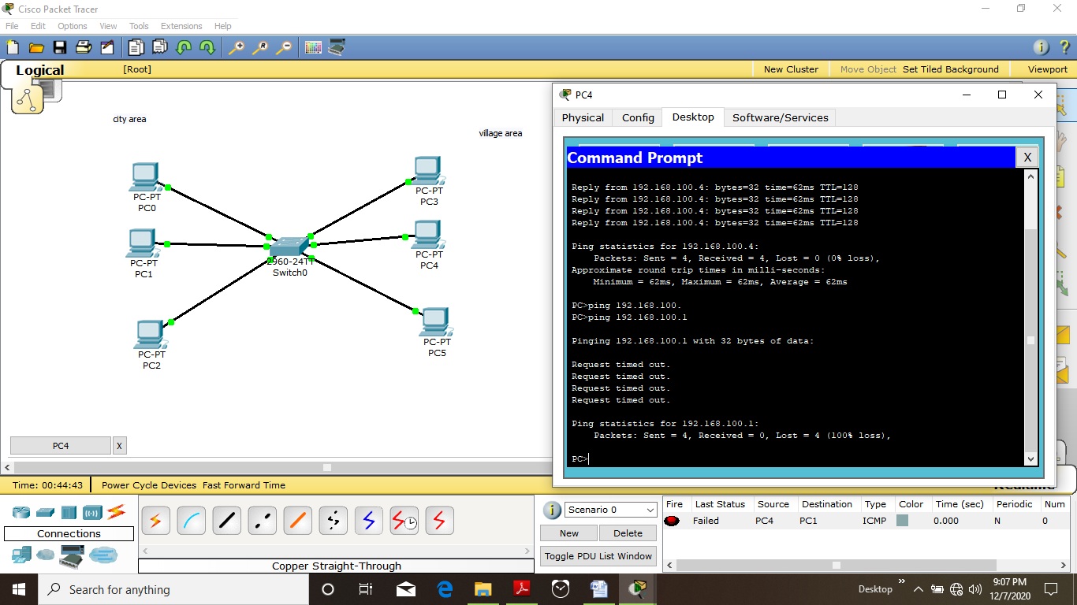

* *Hence we see network is bi-furcated using the concept of VLAN*

*It can also be done via help of CLI*

*But for that we need t know command*

*Commands are as follows*

